# UNIVERSITY OF ENGINEERING AND TECHNOLOGY MARDAN

**NAME : DAWOOD ULLAH SAFI**

**REG NO : 21MDBCS176**

**SUBJECT : HCI**

**SECTION : B**

**SUBMTTED TO : DR.HAMID ullah**

**DEPARTMENT : COMPUTER SCIENCE**

**Assignment# 02**

Assignment: Final Year Project Interface Design and Development

Task #1: Design a PSD Mockup Create a PSD (Photoshop Document) mockup for the user interface of your Final Year Project using any free online design tool. The tools below are recommended, but you can use others as well: • Photopea

• Figma

• Canva

• Vectr

• GIMP

• Pixlr

• Or other free design tools

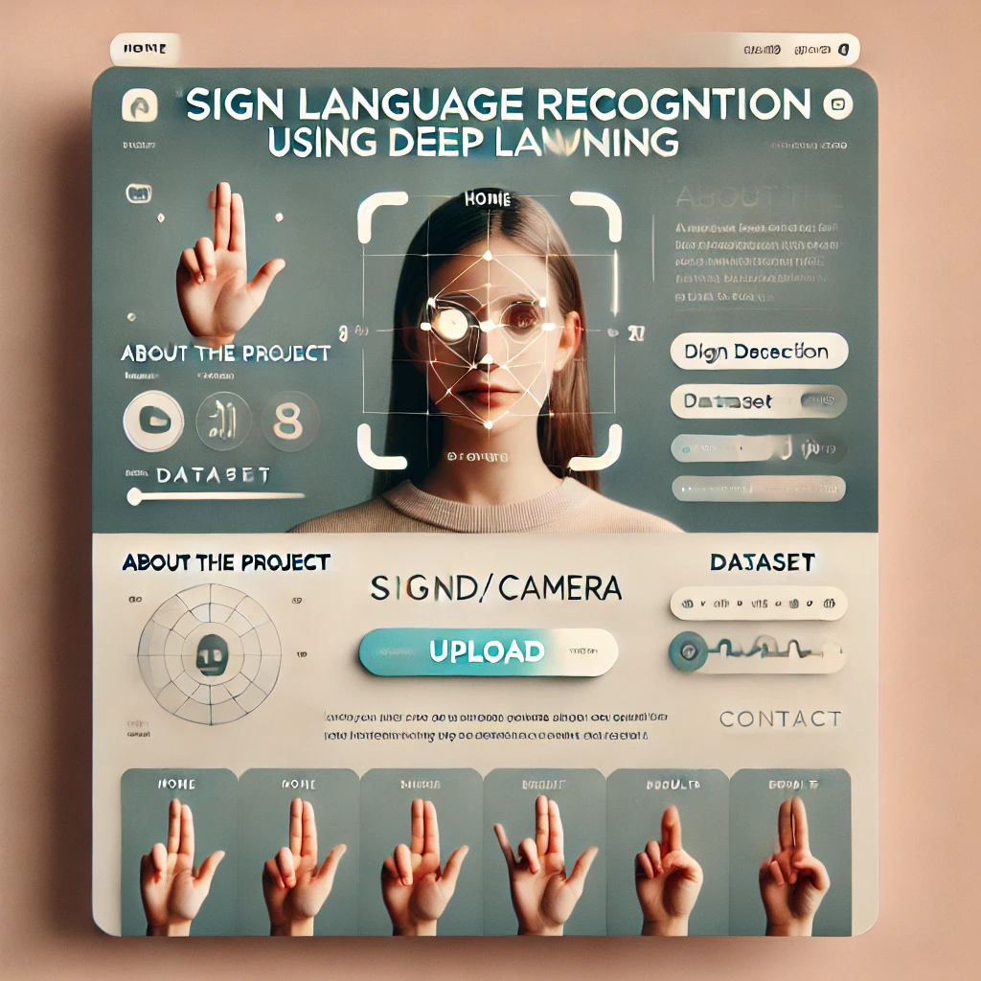

Task #2: Convert PSD to HTML/CSS Convert your PSD mockup from

Task #1into a functional webpage using HTML and CSS. Make sure to structure your code well and apply appropriate styling.

**Here is the html and css code :**

**HTML:**

<!DOCTYPE html>

<html lang="en">

<head>

<meta charset="UTF-8">

<meta name="viewport" content="width=device-width, initial-scale=1.0">

<title>Sign Language Recognition</title>

<link rel="stylesheet" href="style.css">

</head>

<body>

<div class="container">

<div class="header">

<h1>SIGN LANGUAGE RECOGNITION</h1>

<p>Using Deep Learning</p>

<div class="social">

<a href="#"><img src="home.svg" alt="Home"></a>

<a href="#"><img src="camera.svg" alt="Camera"></a>

</div>

</div>

<div class="content">

<div class="left-section">

<div class="about">

<h2>ABOUT THE PROJECT</h2>

<p>Lorem ipsum dolor sit amet consectetur adipisicing elit. Quos, cumque.</p>

<div class="project-info">

<p>Images: <span>2400</span></p>

<p>Dataset: <span>8</span></p>

</div>

</div>

<div class="about">

<h2>ABOUT THE PROJECT</h2>

<div class="project-info">

<p>Images: <span>2400</span></p>

<p>Dataset: <span>8</span></p>

</div>

<div class="project-image">

<img src="project-image.png" alt="Project Image">

</div>

</div>

<div class="hand-signs">

<div class="sign">

<img src="sign1.png" alt="Sign 1">

<p>HOME</p>

</div>

<div class="sign">

<img src="sign2.png" alt="Sign 2">

<p>NONE</p>

</div>

<div class="sign">

<img src="sign3.png" alt="Sign 3">

<p>MUSIC</p>

**CSS:**

<!DOCTYPE html>

<html>

<head>

<title>Sign Language Recognition</title>

<style>

body {

background-color: #f2f2f2;

font-family: sans-serif;

margin: 0;

padding: 0;

}

.container {

display: flex;

justify-content: center;

align-items: center;

height: 100vh;

}

.card {

background-color: #fff;

border-radius: 10px;

box-shadow: 0 2px 5px rgba(0, 0, 0, 0.1);

padding: 30px;

width: 800px;

}

.header {

display: flex;

justify-content: space-between;

align-items: center;

margin-bottom: 20px;

}

.header h1 {

margin: 0;

font-size: 24px;

font-weight: bold;

}

.header .icon {

font-size: 20px;

color: #666;

}

.section {

margin-bottom: 30px;

}

.section-title {

font-size: 18px;

font-weight: bold;

margin-bottom: 10px;

}

.about-project {

display: flex;

align-items: center;

justify-content: space-between;

}

.about-project .left {

display: flex;

align-items: center;

justify-content: center;

width: 150px;

height: 150px;

border-radius: 50%;

background-color: #eee;

}

.about-project .right {

flex: 1;

}

.about-project .right p {

margin: 0;

}

.sign-camera

Task #3: Upload to GitHub Upload both Task #1 (PSD/mockup design) and Task #2 (HTML/CSS implementation) to a GitHub repository. Ensure your repository is organized and includes all necessary files.

**Here is link of github of my repository:**

https://github.com/1DAWOOD/HCI.git